IDEATION PHASE

Brainstorm & Idea Prioritization Template

Date: 25 October 2026
Team ID: __________________
Project Name: StaffSync – Human Resource Management System
Maximum Marks: 4 Marks

Step 1: Team Gathering, Collaboration and Select the Problem Statement
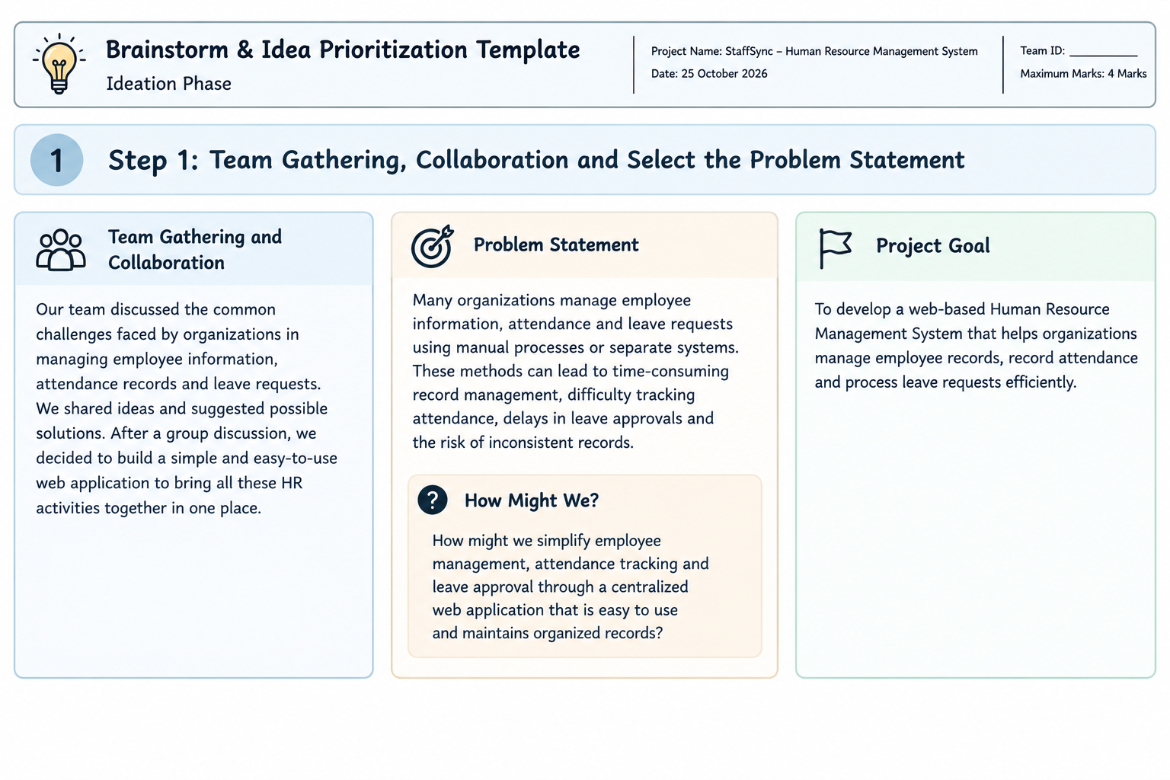
Team Gathering and Collaboration

The project team identified common challenges faced by organizations in managing employee information, attendance records, and leave requests. The team focused on finding a simple digital solution that could organize these HR activities in one centralized platform.

Problem Statement

Many organizations manage employee information, attendance, and leave requests using manual processes or separate systems. These methods can lead to time-consuming record management, difficulty tracking attendance, delays in leave approvals, and the risk of inconsistent records.

StaffSync aims to address these challenges through a web-based Human Resource Management System developed using the MERN stack.

How Might We Question?

How might we simplify employee management, attendance tracking, and leave approval through a centralized web application that is easy to use and maintains organized records?

Project Goal

To develop a web-based HR management application that helps organizations manage employee records, record attendance, and process leave requests efficiently.

Step 2: Brainstorm, Idea Listing and Grouping
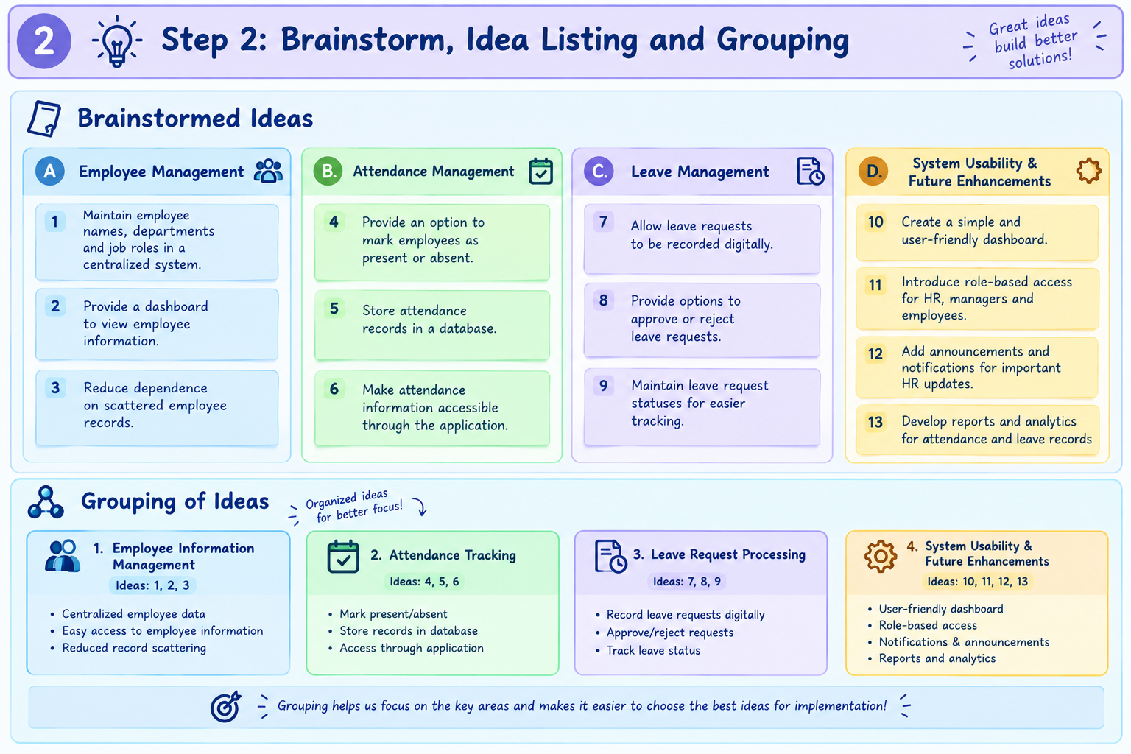

The following ideas were identified as potential solutions to the HR management problems.

A. Employee Management

1. Maintain employee names, departments, and job roles in a centralized system.
2. Provide a dashboard to view employee information.
3. Reduce dependence on scattered employee records.

B. Attendance Management
4. Provide an option to mark employees as present or absent.
5. Store attendance records in a database.
6. Make attendance information accessible through the application.

C. Leave Management
7. Allow leave requests to be recorded digitally.
8. Provide options to approve or reject leave requests.
9. Maintain leave request statuses for easier tracking.

D. System Usability and Future Improvements
10. Create a simple and user-friendly dashboard.
11. Introduce role-based access for HR personnel, managers, and employees.
12. Add announcements and notifications for important HR updates.
13. Develop reports and analytics for attendance and leave records.

Grouping of Ideas

The ideas were grouped into four categories: employee information management, attendance tracking, leave request processing, and future enhancements. This grouping helps organize the project requirements and identify the most useful features for implementation.

Step 3: Idea Prioritization
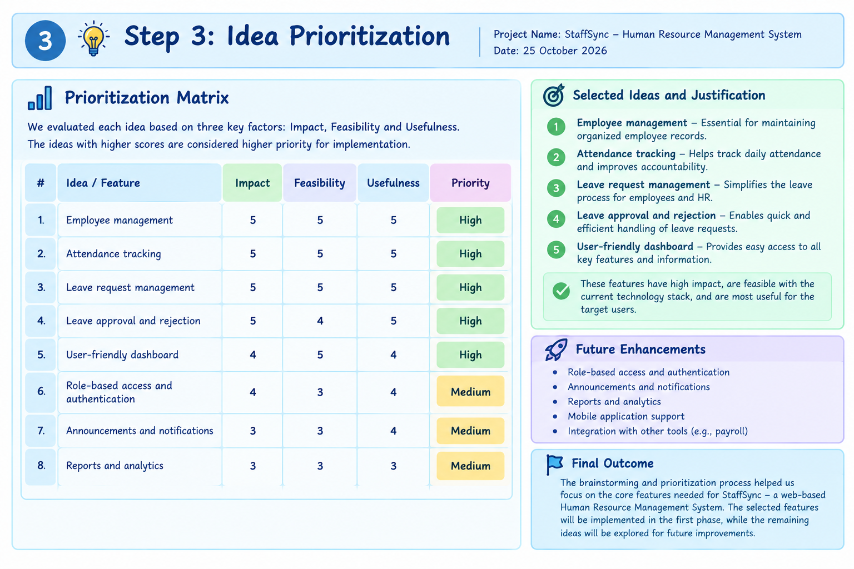
The proposed ideas were prioritized according to their importance, feasibility, and usefulness for the intended users.

Idea. | Impact| Feasibility| Priority
Employee management. | High| High| High
Attendance tracking. | High| High| High
Leave request managemet |.High| High| High
Leave approval and rejection. | High| High| High
User-friendly dashboard. | Medium| High| High
Role-based access and authentication. | High| Medium| Future enhancement
Announcements and notifications. | Medium| Medium| Future enhancement
Reports and analytics. | Medium| Medium| Future enhancement

- Selected Ideas and Justification

The employee management, attendance tracking, and leave management features were selected as the primary project features because they address essential HR activities and can be implemented using the available technology stack.

A user-friendly dashboard was also included to provide convenient access to the main functions. Advanced features such as role-based authentication, notifications, and detailed analytics were identified as potential future enhancements.

Final Outcome

The brainstorming and prioritization process resulted in the selection of StaffSync as a web-based HR management solution. The project focuses on organizing employee information, tracking attendance, and managing leave requests through a centralized application.

The implemented core features include employee management, attendance marking, leave request management, and leave approval or rejection, with application data stored in MongoDB.

